**Second Hands-on**

**Run and Test the Application**

1. **Run SpringLearnApplication (main class)**

**Test endpoints:**

[**http://localhost:8083/hello**](http://localhost:8083/hello)

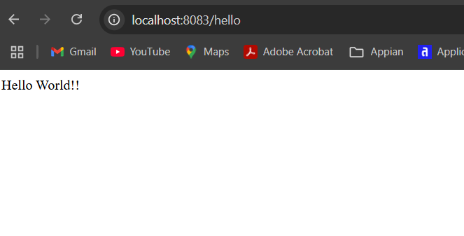

[**http://localhost:8083/country**](http://localhost:8083/country)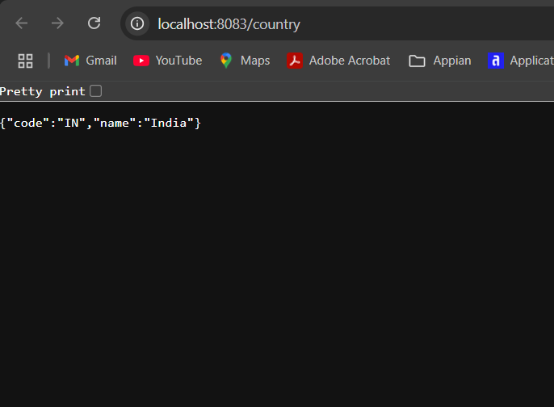

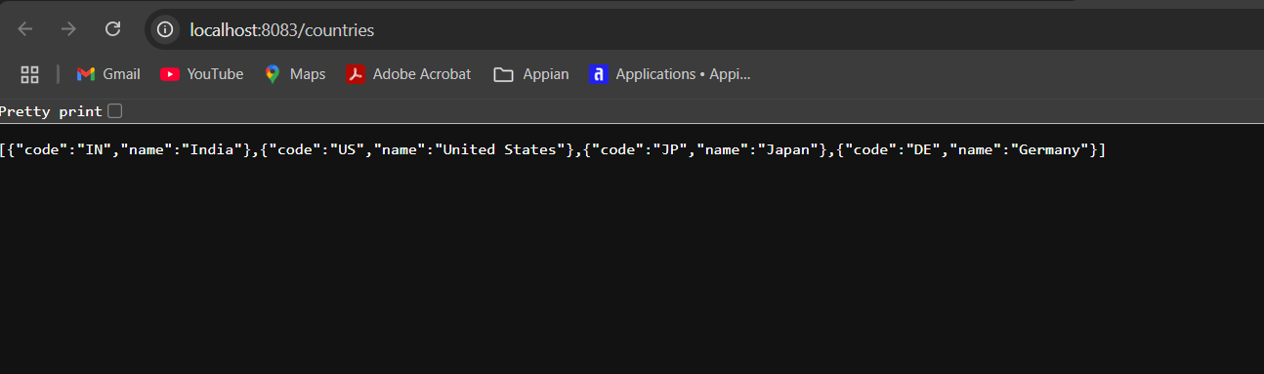[**http://localhost:8083/countries**](http://localhost:8083/countries)

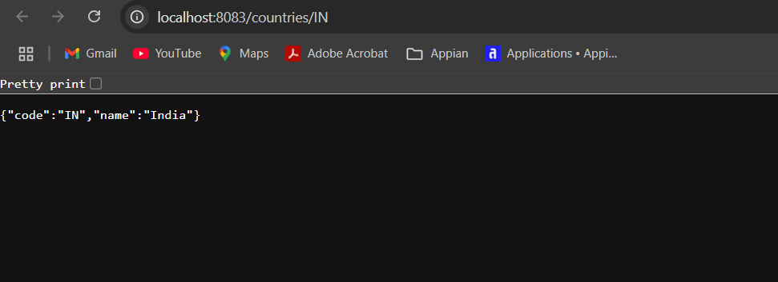[**http://localhost:8083/countries/IN**](http://localhost:8083/countries/IN)

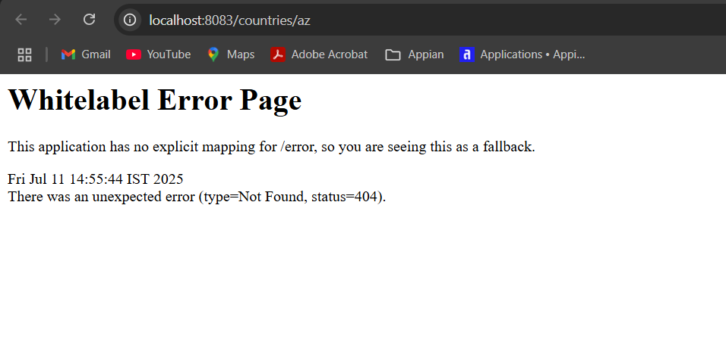[**http://localhost:8083/countries/az**](http://localhost:8083/countries/az)**(should return 404)**